Compliance with Vessel Speed Restrictions to Protect North Atlantic Right Whales

Gregory K. Silber*, Jeffrey D. Adams, Shannon Bettridge, Brandon Sousa

Office of Protected Resources
National Marine Fisheries Service, NOAA
1315 East-West Highway
Silver Spring, MD 20910

*Corresponding author: Greg.Silber@noaa.gov

ABSTRACT: Factors that motivate individuals or businesses to comply with regulations are not always clear. We assessed compliance by vessel operators with regulations aimed at reducing collisions with North Atlantic right whales. Beginning in December 2008, federal regulations required vessels 65 feet or greater in length to travel at speeds of 10 knots or less at prescribed times and locations along the U.S. eastern seaboard. Using remotely-sensed data, we quantified speeds during 160,735 trips made by 8,177 individual vessels between November 2008 and July 2012, constituting a nearly complete census of the regulated population. We examined speeds during trips taken before and after vessel operators received at least one of four information or enforcement notifications. Initial adherence to the regulation was low, but each notification program improved compliance to some degree and together they may have had synergistic effects. Citations accompanied by monetary fines had the greatest impact in reducing the amount and degree of non-compliance, followed in order of effectiveness by notifications via: enforcement-office information letters, monthly summaries of vessel operations, and direct at-sea radio contact. Although only a fraction of the total population received citations accompanied by fines, the effects of those citations appeared to extend well beyond fine recipients and led to improved compliance in the entire regulated community. These results have application to other regulatory systems, especially where remote sensing may be used to monitor activities, and in any setting where compliance with environmental conservation regulations is sought.

Key words: regulatory compliance, remote monitoring, ship strikes, endangered whales

INTRODUCTION
The study of regulatory compliance has received considerable attention in the fields of economics, sociology, and law (see, e.g., Gunningham et al. 2005, Kagan et al. 2011, Tyler 2006). Case studies of regulatory compliance have been conducted in areas as diverse as workplace safety (Gray & Scholz 1993, Mendeloff & Gray 2005), industrial pollution (Kagan et al. 2011), hazardous waste (Stafford 2012), forest clear-cutting practices (Purdy 2010), and fisheries regulations (Ali & Abdullah 2010, Kuperan & Sutinen 1998), among others.
One school of thought suggests the regulated community wishes to act in good faith but this requires both the willingness and capacity (including sufficient understanding of the regulations) to comply (see, e.g., Brehm & Hamilton 1996, Burby & Patterson 1993, INECE 2009). A second theory maintains that those being regulated will act to maximize their own self-interest based on the reasoning that the economic advantages of non-compliance outweigh the consequences of fines or retribution resulting from a lack of compliance (first advanced by Becker 1968, but see also Kagan & Scholz 1984, Tyler 2006, Winter & May 2001) which in turn should prompt regulators to consider appropriate levels of monitoring and financial deterrents to ensure compliance (Ayres & Braithwaite 1992, Gray & Scholz 1993). In some settings businesses may also be motivated by the consequence of acquiring a poor reputation in the eyes of the general public (Gunningham et al. 2005, Karpoff et al. 2005). In any case, to maximize the effectiveness of the regulations they are preparing, regulators should be cognizant of factors, including the role of increasing levels of enforcement, that are likely to prompt compliance.
Regulators may not always have resources for adequate monitoring of compliance rates, particularly if the regulated community is large in geographic scope or exists in remote places. This can lead to inconsistent or weak enforcement paradigms (Gren & Li 2011, Kuehn 1996, Rechtschaffen & Markell 2003). Moreover, compliance is generally assessed using infrequent or irregular interviews (Makkai & Braithwiate 1996, Thornton 2009), surveys (Gunningham et al. 2005, Winter & May 2001), or inspections (e.g., site visits) (Gren & Li 2011, Winter & May 2001, Zaelke, et al. 2005) of the regulated community. Such approaches can lead to the sampling of a small portion of the community and development of an incomplete record (Corneliussen 2004, Vaughn 1992) or may be weakened by incompatibility between compliance metrics(Kagan et al. 2011). These and other variables can make actual compliance rates difficult to quantify (Gray & Shimshack 2011).
Here, we examined the response by a large community to a U.S. federal government regulation and specific responses to efforts to improve compliance. We assessed changes in practices made by a multinational maritime community in response to vessel speed restrictions aimed at reducing the probability of lethal vessel collisions with an endangered large whale species, the North Atlantic right whale. We used a readily accessible remote-sensing technology to develop a monitoring program with substantial granularity to quantify initial adherence to the regulation, responses that followed a suite of steps taken to notify vessel operators of violations, and changes in the community’s behavior following enforcement actions that included citations and monetary retribution.

Collision Threat to Whales
For some large whale species, notably the North Atlantic right whale (Eubalaena glacialis), vessel collisions (or “strikes”) represent a significant threat to the recovery of depleted populations (Clapham et al. 1999, Kraus et al. 2005, NMFS 2005). Over 750 vessel strikes of large whales have been reported, with strikes occurring in all oceans (Van Waerebeek et al. 2007). This reported strike count is a fraction of the actual total because an unknown number of vessel strikes go undetected or unreported. As maritime commerce and associated vessel traffic increases (Corbett 2004), and as some whale populations grow in size, the rate of lethal collisions with whale species is likely to intensify. Various measures to reduce this threat have been used in a number of locations worldwide (IWC 2011, Silber et al. 2012), including limitations on vessel speeds (NMFS 2008, NPS 2003).

Vessel Speed Restrictions
Vessel speed has been identified as a contributing factor in the occurrence and severity of vessel collisions with large whales (Laist et al. 2005, Vanderlaan & Taggart 2007). As vessel speed increases, so does the probability of the occurrence of a collision (Gende et al. 2012), the impact forces involved in a collision (Silber et al. 2010), and the probability of serious injury or death of a whale involved in a collision (Pace & Silber 2005, Vanderlaan & Taggart 2007, Wiley et al. 2011). Evidence suggests that for each one-knot incremental increase in vessel speed the likelihood of a fatal strike increases by a factor of 1.5 (Vanderlaan & Taggart 2007). These findings have prompted the use of vessel speed restrictions as a conservation measure to diminish the threat in various locations (NPS 2003, Tejador et al. 2007).
To address the threat of vessel strikes of North Atlantic right whales, the National Oceanic and Atmospheric Administration’s National Marine Fisheries Service (NMFS) issued regulations that limit vessel speeds in certain “seasonal management areas” (SMA) along the U.S. eastern seaboard (NMFS 2008) (Fig. 1). The regulations went into effect 9 December 2008 and require that all vessels 65 feet and greater in length travel at 10 knots or less (speed over ground) in prescribed areas and at key times that correspond to right whale migration, feeding, and nursery areas, and their co-occurrence with high vessel traffic densities near entrances to sizable ports and other locations.
In U.S. waters, right whales migrate in a relatively narrow coastal band between seasonal feeding areas in waters off New England and seasonal nursery areas off the Georgia/Florida coast. Designed to capture the high density confluence of both whales and vessels, most SMAs extend 20 nautical miles (nm) from the coastline and the restrictions are in effect on rolling bases to coincide with the species’ migratory cycle (Fig. 1). Four SMAs encompass a 20-nm radius around key U.S. port entrances; one mirrors the coastline 20 nm from shore from Wilmington, North Carolina to Savannah, Georgia; two are rectangles extending approximately 20 nm from shore at the entrance to Long Island Sound, New York; and one extends 20 nm from shore in southern Georgia and northern Florida (Fig. 1). Three SMAs of various sizes and distances from shore are positioned near Cape Cod, Massachusetts in important right whale feeding and socializing areas.
While all vessels over 65 feet (including recreational and fishing boats) are subject to the restrictions, vessels engaged in the transport of goods and people represent the bulk of the affected entities. Among these are cargo vessels that include bulk carriers, container ships, and “roll-on, roll-off” (or RO-RO) vehicle transport vessels. Tankers are the largest vessel class studied and they transport primarily fluids such as crude and refined oil. Passenger vessels can include cruise ships as well as ferries.
To put the requirements of the 10-knot speed limits in context, typical at-sea speeds tend to range from 10-16, 15-24, and 20-25 knots for tanker, cargo, and passenger vessels, respectively (McKenna et al. 2012). Tug and tow vessels tend not to exceed 10 knots and most commercial fishing vessels tend not to exceed 12 knots, while some high-speed passenger vessels (e.g., ferries) can routinely exceed 30 knots. Therefore, for some vessels, the restrictions constitute a nearly inconsequential change in behavior, while for others the limits represent a rather substantial shift in customary operating practices.

Notifying the Affected Community
To notify the affected public, NMFS developed an extensive set of awareness-raising programs involving a range of media and distribution outlets both before and after the vessel speed regulations went into effect (Silber & Bettridge 2012). As a result, thousands of printed material items were distributed by United States Coast Guard (USCG) and NMFS personnel, port authorities, marine exchanges, NOAA law enforcement officers, shipping associations, and others, as well as hundreds of messages disseminated by broadcast and electronic media. This program is described in Silber & Bettridge (2012); we provide a summary in Appendix 1.
The vessel speed restrictions were described in the U.S. Coast Pilot, a key navigational aid that contains precautionary notices, information on navigational hazards, and related data that are vital to safe navigation. Carrying and knowledge of the contents of the U.S. Coast Pilot is mandatory for all vessels sailing in U.S. waters, and would, conceivably, be expected to ensure mariner adherence to the requirements of U.S. regulations.
In addition to the actions described in Appendix 1, the regulatory process included notice and the solicitation of public comment on the proposed regulation through an Advanced Notice of Proposed Rulemaking (NMFS 2004), Proposed Rulemaking (NMFS 2006), Notice of Intent to Prepare an Environmental Impact Statement (70 FR 36121), and Notices of Availability of Draft (71 FR 38641) and Final Environmental Impact Statements (73 FR 50962). This included numerous public hearings that involved port and industry representatives in key cities within the affected areas.
Most of the dissemination points in this awareness-raising program were domestic in origin or available to mariners primarily after entering U.S. waters, which may have resulted in limited distribution to “foreign-flagged” vessels, a principal component of ships entering U.S. ports. Nonetheless, given the extent of the outreach programs, we conclude that the regulated community had sufficient exposure to the speed restrictions to warrant adherence to them.

MATERIALS AND METHODS

Monitoring Vessel Operations. Vessel operations in the SMAs were monitored using the Automatic Identification System (AIS), a safety-at-sea navigation technology which vessels are required to maintain and that uses transponders to transmit very high frequency (VHF) radio signals containing static information including ship name, call sign, and country of origin, as well as dynamic information unique to a particular voyage such as vessel location, heading, and speed. Static information is entered manually by a crew member before each voyage is initiated, while dynamic information is incorporated directly into the AIS signal by a Global Positioning System (GPS).
The International Maritime Organization’s (IMO) International Convention for the Safety of Life at Sea requires functioning AIS capabilities on all vessels 300 gross tons or greater. The USCG requires AIS on nearly all vessels sailing in U.S. waters and has established a national network of AIS receivers that provides coverage of nearly all U.S. waters. AIS signals are transmitted several times each minute and the network is capable of handling thousands of reports per minute and updates as often as every two seconds. Therefore, a typical voyage in our study might include the transmission of hundreds or thousands of AIS encoded signals. Due to its geographic coverage and signal transmission rate, AIS provides a detailed and continuously sampled (and therefore highly precise) record of vessel operations for a nearly complete census of the affected community. We analyzed AIS data transmitted between 1 November 2008 and 30 April 2012 by cargo, tanker, and passenger vessels with lengths of 65 feet or greater. Vessel speed analyses were limited to transits that were at least one nm in length and had at least five AIS records. Our AIS data analysis methods are described further in Silber & Bettridge (2010).

Efforts to Improve Compliance. After enactment of the restrictions a number of actions were taken to enhance compliance. Programs (described below in chronological order of implementation) involving direct contact with vessel operators or their parent companies were developed independently and initiated at different times by four federal entities: the USCG, NOAA’s Offices of General Counsel and Law Enforcement, and NMFS Office of Protected Resources.

Informational letters to vessel operators that exceeded the 10-knot speed restriction (Community Oriented Policing and Problem Solving (COPPS) Letters);
- USCG Real-time, at-sea radio hailing of vessel operators exceeding the 10-knot speed restriction;
- The provision of Monthly Summaries of Vessel Operations within the SMAs to selected shipping companies; and
- Notices of Violation and Assessment of civil penalties (NOVAs) to vessel operators egregiously exceeding the 10-knot speed restriction.
There was no coordination between programs about the identity of the operators being contacted or with regard to the mechanics or specifics of the individual programs. With the exception of the Office of Protected Resources’ monthly summary program, we had little or no prior knowledge about the initiation of, or selection criteria for notification under, each of the various notification regimes. Coincidentally, a small group of vessel operators (n=16) were the subject of notification by more than one of these programs (Table 1). We chose not to specifically examine the possible additive effects of these notifications because operators receiving multiple notifications were few relative to the total number of vessels in the entire study.

At-Sea Hailing by Radio. Beginning in mid-February 2009 and continuing intermittently in three separate periods through mid-November 2011 (Fig. 2), USCG personnel used radio communications to directly hail vessels that were exceeding the speed limit in SMAs and request that the vessel slow to appropriate speeds. At-sea communications by the USCG occurred while USCG cutters were on routine patrols or while engaged in other missions, and thus they were opportunistic. This is the only notification that relied on direct visual observation of speed restriction violations, and the only one involving real-time, verbal notification. It also is the only notification action that involved the USCG, the recognized maritime safety and enforcement authority.

Community Oriented Policing and Problem Solving (COPPS) Program. Between September 2009 and January 2010 (Fig. 2), NOAA’s Office of Law Enforcement (OLE) sent informational letters to companies whose vessel operators were subjectively determined by OLE agents, based on AIS data analysis, to have made at least one trip in an SMA that far exceeded the 10 knot limit. These letters were part of OLE’s Community Oriented Policing and Problem Solving (COPPS) program and they were, by design, informative rather than punitive. The letters (hereafter referred to as “COPPS letters”) contained a reminder about the speed restrictions and specific information on where and when the violations occurred.

Civil Penalties. Near the onset of the third full season of speed restrictions, NOAA’s General Counsel Enforcement Section began issuing Notices of Violation and Assessment of civil penalties (NOVAs) to some of the more egregious violators determined by distance, speed, or frequency of violation. In the course of this study, NOVAs were issued to the owners and operators of 18 vessels. We note that hundreds of instances of speed restriction violations were observed. However, due to limited resources and the significant staff time required to build civil cases, OLE field agents focused on a relatively small number of operators that exhibited numerous and flagrant breaches of the regulations.
The first seven NOVAs were issued in November 2010. Two additional NOVAs were issued a month later in December 2010, and the remaining nine were issued in November 2011 (Fig. 2). Depending on the number of violations charged – in most cases, multiple offending trips were cited in the NOVA and fines were cumulative – penalties ranged from $11,500 to $92,000 based on the penalty schedules in effect at the time the violations were charged (current and superseded penalty schedules are available to the public at http://www.gc.noaa.gov/enforce-office3.html).

Monthly Summaries of Vessel Operations. The World Shipping Council (WSC) and the Chamber of Shipping of America (CSA) are two key industry trade associations representing companies that own, operate, or charter vessels. Combined, they represent over 60 companies that control the majority of the world’s commercial shipping fleet.
Both the WSC and the CSA assisted in making their members aware of a voluntary program developed by NMFS Office of Protected Resources that involved the periodic dissemination of information about specific vessel operations. These associations announced the Monthly Summaries of Vessel Operations program to their members and offered an opportunity to participate. A total of 17 shipping companies (13 represented by WSC and 4 represented by CSA; a total of ca. 400 vessels) volunteered to participate. Beginning in December 2010 and for the duration of the study period, NMFS sent spreadsheet reports via e-mail directly to officials of participating companies. The reports provided AIS-based summaries of one month of operations that included: vessel name, date/time of entry into the SMA, speeds when entering and exiting and distance traveled in the SMA, and mean and maximum speeds.
Compliance Metrics. We used several metrics to characterize compliance rates, the magnitude of non-compliance in individual transits, and responses to compliance-enhancing programs. We calculated the percent of total transit distance traveled at greater than 10 knots (PDGT10) and the average for speeds exceeding 10 knots to determine the degree of non-compliance. Generally, we chose to limit use of average speeds to characterize individual trips because averages could be influenced by a relatively low number of either high or low speeds in variable-speed trips. In addition, because AIS signals are transmitted at regular intervals, lower speeds would be more strongly represented than higher vessel speeds, thereby biasing a mean speed calculation downward. We regard PDGT10 as a reasonable measure of non-compliance because it is not influenced by outliers (e.g., particularly fast or slow portions of a given trip) or the distributions of speed values (i.e., a trip that may be characterized by variable speeds), and it provides a standard measure that is independent of transit length or duration.
We acknowledge that in using a threshold of 10.0 knots we are employing a strict measure of compliance. As such, trips that include speeds of, for example, 10.1, 10.5, or 10.9 knots (some mariners may regard these speeds as “10 knots”) and greater would be considered non-compliant. In addition, vessel operators may, for example, have substantially diminished their speeds in response to the regulation relative to those customarily used (e.g., traveled 12 knots as opposed to ordinarily using 18 knots), but would still be regarded as non-compliant. Such nuances in the substantial data set are nonetheless captured by the PDGT10 and “average speeds above 10 knots” measurements because they provided information on the degree of non-compliance.
Using these metrics, we examined vessel speeds and compliance rates for vessels exposed to each of the different notification programs as well as for vessels subject to the rule that received no such notifications. Trips that occurred in the periods before and after receiving a notification were analyzed, as were trips that occurred within the geographic boundaries of the SMAs during the times of the year when the speed restrictions were not in effect.
We chose not to use multivariate, comparative and other statistical inferences to characterize differences between each of the notification groups because operators and their companies were not chosen at random; the data are a near census of every trip taken by the regulated community, making estimates of the relative confidence around central tendencies unnecessary. Also, sample sizes were sufficiently large that virtually any comparison between groups would likely indicate some level of statistical significance that ultimately would provide little added value for regulators seeking to design programs to maximize compliance.
RESULTS

All Transits. During the 45-month study period, 8,177 individual vessels made 160,735 trips (Table 2). Cargo vessels made the most voyages (69%), followed by tankers (30%), and passenger vessels (1%). Of the trips studied, 75,726 were made in SMAs when speed restrictions were in effect (or, “active”) (Table 2).
As a whole, the regulated community changed its behavior in response to the speed restrictions, at least to some degree (Fig. 3). For example, 13.0% of the trips within active SMAs consisted entirely of speeds of 10 knots or less, whereas only 3.8% were at <10 knots or less when the restrictions were not in force (Table 2). The PDGT10 was 82.7% in inactive and 49.6% in active speed restriction periods (Table 2). For those portions of the transits that exceeded 10 knots, average speeds were 1.3 knots lower when restrictions were in effect than in times in which they were not (Table 2).
Compliance rates, as defined by average PDGT10, were only 58.3% and 57.3%, respectively, in the first two periods in which the restrictions were in effect. Only 5.2% of the trips were fully compliant in the first full active period and 5.6% were compliant in the second period (Table 3). However, compliance by the regulated population as a whole increased and average speeds decreased with each subsequent active (Table 3).
Vessel Operators Having Received No Notifications or Fines. The group of vessel operators that received no form of compliance notification consisted of 7,660 individual vessels that made 114,702 trips. Of these, 53,195 trips were made when speed limits were in force (Table 2).
Vessel speeds in this group exhibited patterns much like the entire regulated population. For trips made by this group during all four active speed restriction periods, 10.1% were in compliance with the regulation for the duration of the trip, whereas only 2.6% consisted of voyages entirely under 10 knots when speeds limits were not in effect (Table 3). The number of compliant trips in this group increased with each subsequent active period (Fig. 3) from 4.3% compliance in the first active period to 18.4% compliance in the fourth period. Average PDGT10 decreased in each subsequent active period from 58.6% for the first active period to 41.0% in the fourth period (Table 3).

Vessel Operators That Received Notifications or Fines. Compliance improved in all of the notification groups after initiation of the respective notification programs (Fig. 3). Generally, and as discussed below, NOVA recipients exhibited the greatest change in behavior, those receiving monthly summaries of operations exhibited substantial changes in the number of compliant voyages, while direct contact by the USCG resulted in the least amount of relative change (Figs. 2 & 3). Thus, each of the compliance-improving efforts likely contributed, at least to some degree, to reducing the number of non-compliant trips in the broader regulated population.

NOVA Recipients. The group of vessel operators that received NOVAs, the only group that was subjected to enforcement action and monetary penalties, exhibited the greatest relative change in compliant voyages. It also was the smallest of the groups studied: 18 vessels made 1,584 trips. Of these, 788 vessel transits occurred when speed restrictions were in force (Table 3); 591 occurred before the NOVAs were issued (Table 4).
Compliance rates in this group went from 3.9% for trips taken prior to having received NOVAs to 38.1% in trips taken after receiving NOVAs (Table 4). Shifts toward greater compliance is evident in the distribution of PDGT10 values for trips that occurred before and after the NOVAs were issued (Fig. 3d). In addition, compliance improved in each subsequent active period, increasing from 1.3% in the first active period to 43.6% in the fourth period (Table 3). The average PDGT10 decreased from 61.4% for transits occurring before NOVAs were issued to 16.0% after they were issued (Table 4). Thus, by each of these standards, NOVAs had the greatest impact on changing compliance rates of all groups studied.
The observed magnitude of this change can be attributed, at least in part, to the composition of this group. By definition, its operators were singled-out following repeated and rather egregious violations and therefore changes in their behavior might be expected to be of greater magnitude than the broader regulated population. Also, this group was composed primarily of cargo vessels, which generally travel the fastest among the vessel classes studied. In this regard, vessels in this group had the highest average speeds above 10 knots of all groups studied (Table 4). It is noteworthy, however, that even after having received monetary penalties, 38.1% of the trips made by NOVA-recipients were non-compliant and exceeded 10 knots for an average of 16.0% of the trip, and non-compliant trips averaged 12.7 knots (Table 4).

COPPS Letter Recipients. A total of 85 vessel operators received COPPS letters. Their vessels made 4,869 voyages, 2,284 of which occurred during active periods (Table 3) with 912 occurring before the COPPs letters were issued (Table 4).
Relative to the other groups studied, the COPPS program was moderately successful in prompting adherence to the speed regulation (Figs. 2 & 3). Overall, vessel operators in this category took trips wholly at or below 10 knots 10.4% of the time when restrictions were in place and 2.4% of the time when they were not (Table 3). In those times in which the restrictions were in force, 2.9% of the trips taken by this group were completely at or below 10 knots before the letters were sent and 15.4% were at or below 10 knots following the issuance of letters (Table 4, Fig 3a), indicating a clear but modest response to the program. Average non-compliant speeds decreased by only 0.8 knots in trips that occurred after COPPS letters (Table 4), but the number of compliant trips increased in the in the course of the study (Table 3). Average PDGT10 values also decreased in each subsequent active period (Table 3).

WSC Member Monthly Summary Recipients. This group was the largest studied, involving 334 different vessels that made 32,921 trips. Of these, 16,292 trips were made when speed restrictions were in effect (Table 3) and 7,986 occurred before the monthly summaries program began (Table 4).
For trips that occurred when restrictions were not in effect, this group had the lowest rate (0.8%) of trips entirely at or below 10 knots of all groups studied (Table 3). The average PDGT10 for trips made by this group was 85.1% reflecting, in part, this group’s composition of ships that normally operate at speeds that are faster than the other groups studied.
Based on the metrics we used, this group made some of the largest adjustments in operations of all groups (second only to NOVA recipients), following the introduction of this program. Rates of compliant trips for this group went from 3.9% before summaries were provided to 28.7% after the program began (Table 4). However, average non-compliant speeds changed little in trips taken before and after initiation of this notification program (Table 4), indicating that some fast trips were still being taken after implementation of the program. Nonetheless, compliance improved in successive active periods, increasing from a low of 3.2% in the first active period to a high of 36.4% in the fourth period (Table 3). Likewise, the average PDGT10 steadily decreased from 54.1% in the first active period to 25.1% in the fourth (Table 3).

CSA Member Monthly Summary Recipients. A total of 41 different CSA member vessel operators received monthly summaries. They took 7,221 trips in the course of our study, 3,328 of which were made when speed restrictions were in effect (Table 3).
In a number of ways, the CSA monthly summary recipients were different from the other groups studied. One-third of the trips made by this group were fully at or below 10 knots even when speed restrictions were not in force (Table 3), and many of the vessels in this group made trips that were fully compliant during the first active period, the highest rates of all groups studied (Table 4, Fig. 3 & 4b). Unlike other groups, when speed restriction zones were in effect, 41.2% of the trips made by these vessels were fully compliant (Table 3). The average PDGT10 when restrictions were not in effect was 62.2%, but this decreased to 42.6% when restrictions were in effect (Table 3).
While compliance was relatively high in this group at the onset of the regulation, compliance rates also improved over the course of the study. In fact, compliance rates by CSA members in the third and fourth active speed restriction periods were the highest of the entire study (Table 3). The compliance rate of 55.3% for this group following the implementation of the monthly summary program was the highest, and its average PDGT10 (12.4%) was the lowest, of all groups (Table 4). However, non-compliant speeds were virtually unchanged in trips taken before and after the monthly summary program was first instituted (Table 4), indicating that these vessels were already traveling slower than vessels in the other groups studied.
USCG At-sea Hailing Recipients. A total of 48 different vessels were contacted during their trip by the USCG while at sea. These vessels made 2,301 trips with 1,162 occurring when speed limits were in effect (Table 3).
Although this program involved a direct and real-time verbal notification of violation of the speed restriction regulation, it had less impact on improving compliance than the other notification types. These vessels exhibited little overall change in compliant trips in the first three active speed restriction periods, even after they had received USCG contact (Table 3). Prior to being hailed by the USCG, 0.9% of the voyages by this group were compliant and 9.7% were in compliance after being hailed (Table 4), thus representing the smallest relative change of all groups studied. The change in average PDGT10 for all active period transits before and after the USCG hailed these vessels (from 72.8% to 51.2%) (Table 4) also represented a relatively small change in compliant behavior when compared to the other groups. The distribution of PDGT10 transits also differed from the other groups in that these vessels had greater proportions of fast transits than did all other groups (Fig. 4). Voyages taken by vessels that had been contacted by the USCG also had the highest average speeds of all groups during non-compliant trips (Table 4).

DISCUSSION
In his book published in 1971, the late C.B. Bowles stated that “20 percent of the regulated population will automatically comply with any regulation, 5 percent will attempt to evade it, and the remaining 75 percent will comply as long as they think that the 5 percent will be caught and punished” (Bowles 1971). Whereas our study may not be able to verify Bowles’ statement, we offer new information about compliance rates in a regulated community, particularly as it pertains to the influence of specific punitive and non-punitive actions designed to enhance compliance. We found that while some of the community responded when first confronted with the novel regulation, a large portion did not. We observed progressively improving compliance rates that were influenced most strongly by the threat (or reality) of enforcement activities. Perhaps in this case, a large portion of Bowles’ 75% was awakened after the 5% received monetary penalties.
Adherence to regulations relies on an adequate understanding of the rules, the capacity and willingness to comply (see, e.g., Burby & Patterson 1993, INECE 2009, Tyler 2006), and perhaps ultimately on the influence of monitoring and enforcement activities (Gunningham & Kagan 2005, May 2005, Thornton 2009). Sizable financial deterrents may not always be necessary to ensure compliance (Gray & Scholz 1991), particularly when public perception and social pressures are at play (see, e.g., Winter & May 2001, Guggenheim et al. 2005, Kagen et al. 2011). The “stick” as opposed to the “carrot” can generate substantial general deterrence and the response can be evident beyond those who are the subject of enforcement actions (Gray & Shimshack 2011). Punitive actions can also provide a backdrop whereby incentives or non-punitive measures can function more effectively (see, e.g., Abbot 2009, Scholz & Gray 1990).
Vessel speed restrictions were a novel regulation that required the modification of customary operations by a large international shipping community that had not previously been regulated in this way and on this scale. Descriptions of the rule’s requirements were provided through a host of outreach media. Our findings suggest, however, that extensive efforts to inform the public about the regulation provided no assurances that widespread compliance would necessarily follow. It is beyond the scope of this study to determine if low initial compliance rates were indicative of inadequate knowledge of the restrictions or whether entities knew of the regulation but chose not to comply. Regardless, indications are that monitoring and enforcement activities were needed to ensure meaningful changes in behavior.
Changes in behavior made by NOVA recipients illustrates the influence of enforcement actions and monetary fines. Compliance of all the groups receiving a form of notification tended to mimic the regulated population as a whole, therefore it is difficult to determine with certainty which notifications had the greatest general impact. However, this can be gauged by examining the timing of each of the notifications. Discernible changes in behavior in the entire regulated community were evident after monetary penalties were issued near the beginning of the third speed limit period (Fig. 3). Neither the USCG direct radio contact nor the COPPS letter programs (both occurring at the onset of the second full active period) were able to generate such a community-wide change. We conclude that the issuing of citations to this group, although containing the smallest number of individuals of all the groups, had the greatest overall impact on improving compliance in the population as a whole. Word of enforcement actions apparently spread quickly through much of the regulated population as evidenced by the rapid decline in non-compliant trips made by the entire community following the issuance of NOVAs. The rate of non-compliant trips made by the entire regulated community continued to decline at the end of our study, probably resulting from a second round of NOVAs in late 2011.
Direct contact by the USCG during a non-compliant voyage would seemingly be one of the most powerful tools to improve compliance. The USCG is the recognized maritime safety and enforcement authority in U.S. waters, and it was the only notification action that occurred in real time. Nonetheless, while vessel speeds decreased in trips that followed having been hailed, this approach had the weakest overall influence on improving compliance. This suggests that if the perceived likelihood of detection is low (i.e., no USCG cutter in sight), the threat of adverse consequences is likewise low. Whereas USCG hailing actions likely were not reported to industry management, notifications sent directly to the operating company were likely to be addressed by company-wide administration, and therefore have a greater overall effect, especially in the case of NOVAs.
The relatively small changes in the number of compliant trips by CSA members can be attributed to the composition of this group. The CSA represents a diverse set of vessel types including tankers, RO-ROs, and cargo vessels. At-sea speeds for tankers tends to be around 10-12 knots (McKenna et al. 2012), and therefore the speeds of CSA-member vessels likely were not substantively affected by the speed restrictions. In addition, awareness raising efforts by this association, through general e-mail notification campaigns both before and after the speed limits went into effect, were probably a factor in compliance behavior as well.
We believe each of the notification/enforcement programs had synergistic effects in improving compliance, consistent with findings by Gray & Shimshack (2011) and Stafford (2012). The industry feedback programs, in particular, appeared to complement limited enforcement actions because they reached a large number of vessel operators, owner, and administrators, and were made known company-wide. They also reinforced the power of citations by providing periodic reminders that operations were routinely being watched.
Challenges to ensuring compliance exist in settings where limited resources may lead to infrequent inspection of regulated firms (Harrington 1988, Friesen 2003, OECD 2003), if enforcement activities are limited in remote locations or if the regulated population is large or widely dispersed (Abbott 2009, Ali & Abdullah 2010). Purdy (2009) advocated for the use of remote sensing technologies (specifically, Earth-orbiting satellites) to monitor and enforce environmental regulations such as forest clear-cutting and farming practices. Use of AIS or a related remote-sensing technology may provide cost-effective tool to improve compliance in other whale collision reduction, or related maritime, regulatory settings. Indeed, nearly all components of the programs described here were accomplished remotely: implementing, monitoring, and enforcing the restrictions; and developing and initiating public education and mariner feedback programs. Therefore, in contrast to labor-intensive inspections (or vessel boardings, for example) and other enforcement activities used in most regulatory settings, this system and most of its components were highly cost-effective.
We provide an assessment, involving considerable granularity, of levels of compliance with a wildlife conservation regulation and a quantification of the relative effectiveness of steps taken to prompt improved levels of adherence to a specific rule. These results may aid in the formulation of management strategies for this particular conservation concern and help guide decisions in virtually any setting in which regulatory compliance is sought.

Acknowledgements
We are grateful to Kam Chin and David Phinney of the John A. Volpe National Transportation Systems Center for their assistance and guidance in the acquisition and analysis of vessel AIS data. The USCG National AIS program has been invaluable to this and other vessel operation analyses. We thank the World Shipping Council and the Chamber of Shipping of America for their assistance in making their members aware of NOAA’s program to share compliance data with vessel owners, operators, and charterers. Comments provided by Duane Smith improved the manuscript. One of us (GKS) dedicates this paper to Robert Silber whose lifetime of innovation and his compassion in service to others has provided ongoing inspiration.
LITERATURE CITED

Abbot C (2009). Enforcing pollution control regulation: Strengthening sanctions and improving deterrence. Oxford: Hart Publishing

Ali J, Abdullah H (2010). Impact of enforcement and co-management on compliance behavior of fishermen. International Journal of Economics and Finance, 2, 113-121

Ayres I, Braithwaite J (1992). Responsive regulation: Transcending the deregulation debate. New York: Oxford University Press

Becker G (1968). Crime and punishment: An economic approach. Journal of Political Economy, 76, 169-217

Bowles C (1971). Promises to keep: My years in public life, 1941-1969. New York: Harper & Row

Brehm J, Hamilton JT (1996). Noncompliance in environmental reporting: Are violators ignorant, or evasive, of the law? American Journal of Political Science, 40, 444-477

Burby RJ, Paterson RG (1993). Improving compliance with state environmental regulations. Journal of Policy Analysis and Management, 2, 753-772

Clapham PJ, Young SB, Brownell Jr. RL (1999). Baleen whales: Conservation issues and the status of the most endangered populations. Mammal Review, 29, 35-60

Corneliussen F (2004). Justifying non-compliance: A case study of a Norwegian biotech firm. Centre for Analysis of Risk and Regulation Discussion Paper Series, No. 20. London School of Economics and Political Science

Corbett JJ (2004) Marine transportation and energy use. In C. J. Cleveland (Ed.), Encyclopedia of Energy. San Diego: Elsevier Science

Friesen L (2003) Targeting enforcement to improve compliance with environmental regulations. Journal of Environmental Economics and Management, 46, 72-85

Gende S, Hendrix N, Harris K, Eichenlaub B, Nelson J, Pyare, S (2011) A Bayesian approach for understanding the role of ship speed in whale-ship encounters. Ecological Applications, 21, 2233-2240.

Gray WB, Shimshack JP (2011) The effectiveness of environmental monitoring and enforcement: A review of the empirical evidence. Review of Environmental Economics and Policy, 5, 3-24

Gray WB, Scholz JT (1991) Analyzing the Equity and Efficiency of OSHA Enforcement. Law and Policy, 13, 185-214

Gray WB, Scholz JT (1993) Does regulatory enforcement work? A panel analysis of OSHA enforcement. Law and Society Review, 27, 177-213

Gren I-M, Li C-Z (2011. Enforcement of environmental regulations: inspection costs in Sweden. Environmental Economics, 2, 50-58

Gunningham N, Kagan RA (2005) Regulation and business behavior. Law and Policy, 27, 213-218

Gunningham ND, Thornton D, Kagan RA (2005). Motivating management: Corporate compliance in environmental protection. Law and Policy, 27, 289-316

Harrington W (1988) Enforcement leverage when penalties are restricted. Journal of Public Economics, 37, 29-53

Helland E (1998) The enforcement of pollution control laws: Inspections, violations, and self-reporting. Review of Economics and Statistics, 80, 141-153

International Network for Environmental Compliance and Enforcement (2009) Principles of environmental compliance and enforcement handbook. U.S. Environmental Protection Agency Document Number 300F09002

International Whaling Commission (IWC) (2011) Report of the joint IWC-ACCOBAMS workshop on reducing risk of collisions between vessels and cetaceans. International Whaling Commission, London

Jensen AS, Silber GK (2003) Large Whale Ship Strike Database. U.S. Department of Commerce, NOAA Technical Memorandum, NMFS-F/OPR-25

Kagan RA, Scholz JT (1984) The criminology of the corporation and regulatory enforcement strategies. In K. Hawkins, et al. (Eds.), Enforcing Regulation. The Hague: Kluwer-Nijhoff Publishing

Kagan RA, Gunningham N, Thornton D (2011) Fear, duty, and regulatory compliance: Lessons from three research projects. In C. Parker & V. L. Nielsen (Eds.), Explaining compliance: Business responses to regulation. Cheltenham: Edward Elgar Publishing

Karpoff J, Lott J, J, Welby E (2005) The reputational penalties for environmental violations: Empirical evidence. Journal of Law and Economics, 68, 653-675

Kraus SD, Brown MW, Caswell H, Clark CW, Fujiwara M, Hamilton PK, Kenney RD, Knowlton AR, Landry S, Mayo CA, McLellan WA, Moore MJ, Nowacek DP, Pabst DA, Read AJ, Rolland RM (2005) North Atlantic right whales in crisis. Science, 309, 561-562

Kuehn RR (1996) The limits of devolving enforcement of federal environmental laws. Tulane Law Review, 70, 2373-2378

Kuperan K, Sutinen JG (1998) Blue water crime: Deterrence, legitimacy, and compliance in fisheries. Law and Society Review, 32, 309-337

Laist DW, Knowlton AR, Meade J, Collet AS, Podesta M (2001) Collisions between ships and whales. Marine Mammal Science, 17, 35–75

Makkai T, Braithwaite J (1996) Procedural justice and regulatory compliance. Law and Human Behavior, 20, 83-98

May PJ (2005) Compliance motivations: Perspectives of farmers, homebuilders, and marine facilities. Law and Policy, 27, 317-347

McKenna MF, Ross, D, Wiggins, SM., Hildebrand, JA (2012) Underwater radiated noise from modern commercial ships. Journal of the Acoustical Society of America, 131, 92-103

Mendeloff J, Gray, WB (2005) Inside the black box: How do OSHA inspections lead to reductions in workplace injuries? Law and Policy, 27, 219-237

National Marine Fisheries Service (2004) Advanced notice of proposed rulemaking for right whale ship strike reduction. U.S. Department of Commerce. 69 FR 30857, 1 June 2004

National Marine Fisheries Service (2005) Recovery plan for the North Atlantic Right Whale (Eubalaena glacialis), revision. U.S. Department of Commerce, National Marine Fisheries Service, Office of Protected Resources

National Marine Fisheries Service (2006) Proposed rule to implement speed restrictions to reduce the threat of ship collisions with North Atlantic Right Whales. U.S. Department of Commerce. 71 FR 36299, 26 June 2006.

National Marine Fisheries Service (2008) Final rule to implement speed restrictions
to reduce the threat of ship collisions with North Atlantic Right Whales. U.S. Department of Commerce. 73 FR 60173, 8 November 2008

National Park Service (2003) Glacier Bay National Park and Preserve, Alaska: Vessel quotas and operating requirements final environmental impact statement. Glacier Bay National Park and Preserve, U.S. Department of Interior

Pace RM, Silber, GK (2005) Simple analysis of ship and large whale collisions: Does speed kill? Poster presented at the Sixteenth Biennial Conference on the Biology of Marine Mammals, San Diego, CA. December 2005

Purdy R (2010) Using Earth observation technologies for better regulatory compliance and enforcement of environmental laws. Journal of Environmental Law, 22, 59-87

Rechtschaffen C, Markell DL (2003) Improving state environmental enforcement performance through enhanced government accountability and other strategies. Environmental Law Reporter, 33, 10559-10596

Scholz JT, Gray WB (1990) OSHA Enforcement and workplace injuries: A behavioral approach to risk assessment. Journal of Risk and Uncertainty, 3, 283–305

Silber GK, Bettridge S (2010) Vessel operations in right whale protection areas in 2009. U.S. Department of Commerce, NOAA Technical Memorandum, NMFS-OPR-44

Silber GK, Slutsky J, Bettridge S (2010) Hydrodynamics of a ship/whale collision.
Journal of Experimental Marine Biology and Ecology, 391, 10-19

Silber GK, Bettridge S (2012) An assessment of the Final Rule to implement vessel speed
restrictions to reduce the threat of vessel collisions with North Atlantic right whales. U.S. Department of Commerce, NOAA Technical Memorandum, NMFS-OPR-48

Silber, G.K., Adams, J.D., & Bettridge, S. (2012). Vessel Operator Response to a Voluntary
Vessel/Whale Collision Reduction Measure. Endangered Species Research, 17, 245–254

Stafford S (2012) Do carrots work? Examining the effectiveness of EPA’s compliance assistance program. Journal of Policy Analysis and Management, 31, 533–555

Tejedor A, Sagarminaga R, Cañadas A, de Stephanis R, Pantoja J (2007) Modifications of maritime traffic off southern Spain. Document presented to the Scientific Committee of the International Whaling Commission. SC/59/BC13

Thornton D (2009) When social norms and pressures are not enough: Environmental performance in the trucking industry. Law and Society Review, 43, 405-434

Tyler TR (2006) Why people obey the law. Princeton: Princeton Press

van der Hoop JM, Vanderlaan ASM, Taggart CT (2012) Absolute probability of lethal vessel-strikes to North Atlantic right whales in Roseway Basin, Scotian Shelf. Ecological Monographs, Ecological Society of America. In press

Vanderlaan ASM, Taggart CT (2007) Vessel collisions with whales: The probability of lethal injury based on vessel speed. Marine Mammal Science, 23, 144-156
Vaughn D (1992) The macro-micro connection in white-collar crime theory. In K. Schlegel & D. Weisburd (Eds.), White-collar crime reconsidered. Boston: Northwestern University Press

Van Waerebeek K, Baker AN, Felix F, Gedamke J, Iniguez M, Sanino GP, Secchi E, Sutaria D, van Helden A, Wang Y (2007) Vessel collisions with small cetaceans worldwide and with large whales in the Southern Hemisphere, an initial assessment. Latin American Journal of Aquatic Mammals, 6, 43-69

Ward-Geiger LI, Silber GK, Baumstark RD, Pulfer TL (2005) Characterization of ship traffic in right whale critical habitat. Coastal Management, 33, 263-278

Wiley D., Thompson M, Pace III RM, Levenson J (2011) Modeling speed restrictions to mitigate lethal collisions between ships and whales in the Stellwagen Bank National Marine Sanctuary, USA. Biological Conservation, 144, 2377-238

Winter SC, May PJ (2001) Motivation for compliance with environmental regulations. Journal of Policy Analysis and Management, 20, 675-698

Zaelke D, Kaniaru D, Kruzikova E (2005) Making law work: Environmental compliance
and sustainable development, 2, 372-375
Appendix 1. List and description of media used to notify mariners of the December 2008 vessel speed restrictions.

- Maritime Broadcasts. USCG Broadcast Notice to Mariners (marine radio broadcasts), Local Notice to Mariners (updated weekly and distributed electronically), NOAA maritime weather broadcasts, and notifications on NOAA Weather Buoy websites. These are key sources of information frequently consulted by prudent mariners sailing in U.S. waters.
- International Sailing Publications. The National Geospatial Intelligence Agency’s Notice to Mariners and Sailing Directions, and to the United Kingdom’s Admiralty Publications. Updated and published annually, these international guidance documents are distributed broadly and are essential guides for mariners on international voyages.
- Nautical Charts. The management zones, their timing, and applicable restrictions were noted on printed nautical charts, a mainstay for navigational safety.
- Outgoing messages to specific vessels entering right whale aggregation areas and as required to report their presence through two Mandatory Ship Reporting systems (see Ward et al. 2005 for a description).
- Informational Brochures. Laminated two-page compliance guides distributed and posted on web sites. An estimated 3,000 guides were distributed. http://www.nmfs.noaa.gov/pr/pdfs/shipstrike/compliance_guide.pdf
- Captain and Crew Training Material. A merchant mariner training curriculum designed primarily for maritime academies. Training through these academies is essential for those seeking captain’s licenses or upgrades to their license and the ship strike reduction curriculum is required in most U.S. academies. Interactive CD-ROMs. Captain and crew interactive training compact discs and “Right Whale Protection Program” notebooks were also developed. An estimated 2,500+ CDs and over 550 notebooks were distributed at no cost to the user.
- Electronic Distribution Lists. NMFS maintained electronic mail distribution lists for the shipping industry (containing several hundred recipients). Similar distributions were made via electronic mail lists (also containing owners and operators of several hundred vessels) maintained by industry associations, whereby their member companies were notified.
- Agency and Company Information Dissemination. Electronic mail notices were periodically and routinely distributed by the U.S. Maritime Administration (MARAD) to its entire fleet of 5,000+ domestically-flagged vessels. MARAD maintains or has jurisdiction over these commercially-operated material transport and cargo vessels that are pressed into service in time of war or national emergency as naval auxiliaries. A similar number of vessels were routinely notified about the requirements by Lloyds Registry.
- Popular Press. Press releases issued and over 20 articles published in industry trade journals.

List of Tables and Figures
Table 1. Counts for vessel operators receiving more than one notification.
Table 2. Compliance measures and number of vessels and transits for each of five notifications (see text for descriptions) in periods when speed restrictions were (active) and were not (inactive) in force between November 2008 and July 2012.
Table 3. Compliance measures and numbers of vessels and transits for each of the periods in which speed restrictions were in effect (e.g., “active” periods) between December 2008 and August 2012.
Table 4. Summary of compliance measures for vessel transits that occurred during periods when speed restrictions were in effect both before and after each of five notifications began.
Figure 1. Locations, names, and active periods of vessel speed restriction Seasonal Management Areas (SMAs).
Figure 2. Timeline of the initiation and cessation or continuance of notification programs. The five notification programs are listed on the y-axis and the period from November 2008 until July 2012 is represented on the x-axis with each hash mark representing one month. The USCG and COPPS notifications are depicted with a hatched rectangle to denote the intermittent nature of those programs, with no set frequency for notifications. NOVAs are represented by a letter icon denoting the three dates that groups of NOVAs were sent out, and the filled line represents the continuing process of litigation and settlement that occurs after an assessment of a monetary fine. The WSC and CSA programs are represented with a filled line, denoting the regular (monthly) reporting. The WSC, CSA, and NOVA (NOVAs could conceivably be issued at any time) notification programs continue; their timelines end with an arrow denoting continuation past July 2012.
Figure 3. Scatter plots of PDGT10 values (see text for description) from Migratory and Calving/Nursery Grounds SMAs (see Figure 1) transits for (a) NOVA, (b) COPPS letter, (c) CSA monthly summary, and (d) and WSC monthly summary recipients. Gray dashed line depicts monthly PGDT10 averages for the entire regulated community and solid dark lines depict the monthly averages for the respective notification group. Periods when speed restrictions were in effect (i.e., active periods) are shown at the top of the plots and the time at which the notification action was initiated is depicted with a dashed vertical line (COPPs letters were issued over a 3 month period).
Figure 4. Histograms and box plots (located below histograms) depicting the distribution of “% of distance > 10 knots” (see text for description) values for (a) COPPS letter, (b) CSA monthly summary (c) WSC monthly summary, (d) NOVA, and (e) USCG at-sea-hailing recipients. Figures on the left depict distributions for all inactive period transits and the middle and right histograms depict the distribution for all active period transits that occurred before and after the management action, respectively. Rectangles in the box plots represent the middle 50% of the data, or interquartile range (IQR). Median PDGT10 values are represented with lines inside the boxes, and the T-shaped lines extending from the boxes represent upper (largest observation less than or equal to the 75th percentile plus 1.5 times IQR) and lower (smallest observation that is greater than or equal to the 25th percentile minus 1.5 times IQR) adjacent values.
Table 1.
Notification Combinations | Number of Vessels
COPPS letter and USCG At-sea Hailing | 1
Monthly Summary and COPPS letter | 9
Monthly summary and NOVA | 3
Monthly Summary and USCG At-sea Hailing | 3
Total | 16
Table 2.

Group | SMA Status | Vessels | Transits | % of Transits  in Compliance¹ | Avg PDGT10 | Avg Speed  when >10 knots
All Transits | Inactive | 6,244 | 85,009 | 3.8 | 82.7 | 14.1
All Transits | Active | 6,263 | 75,726 | 13.0 | 49.6 | 12.8
No Management Action | Inactive | 5,772 | 61,507 | 2.6 | 82.5 | 13.8
No Management Action | Active | 5,751 | 53,195 | 10.1 | 51.5 | 12.3
COPPS Letter | Inactive | 77 | 2,585 | 2.4 | 87.3 | 14.6
COPPS Letter | Active | 85 | 2,284 | 10.4 | 50.7 | 13.3
Monthly Summary (CSA) | Inactive | 37 | 3,893 | 33.3 | 62.6 | 11.4
Monthly Summary (CSA) | Active | 41 | 3,328 | 41.2 | 42.6 | 11.1
Monthly Summary (WSC) | Inactive | 321 | 16,629 | 0.8 | 85.1 | 14.6
Monthly Summary (WSC) | Active | 334 | 16,292 | 16.6 | 41.1 | 12.6
NOVA | Inactive | 17 | 796 | 1.4 | 86.6 | 14.8
NOVA | Active | 18 | 788 | 12.4 | 57.1 | 13.5
USCG At-sea Hailing | Inactive | 36 | 1,139 | 2.9 | 86.1 | 15.1
USCG At-sea Hailing | Active | 48 | 1,162 | 5.7 | 64.8 | 13.2
¹During inactive periods when speed restrictions were not in effect, compliance refers to transits for which all speeds were ≤ 10 knots
Table 3.

Group | Active Period | Vessels | Transits | % of Transits  in Compliance | Avg PDGT10 for Noncompliant Transits | Avg Noncompliant Speed
All Transits | 1 | 2,286 | 15,510 | 5.2 | 58.3 | 13.0
All Transits | 2 | 2,586 | 19,539 | 5.6 | 57.3 | 12.8
All Transits | 3 | 2,659 | 20,710 | 15.1 | 44.1 | 12.6
All Transits | 4 | 2,655 | 19,967 | 24.1 | 38.2 | 12.5
No Management Action | 1 | 1,966 | 11,298 | 4.3 | 58.6 | 12.4
No Management Action | 2 | 2,231 | 13,558 | 4.7 | 58.6 | 12.3
No Management Action | 3 | 2,267 | 13,646 | 11.1 | 48.0 | 12.2
No Management Action | 4 | 2,359 | 14,693 | 18.4 | 41.0 | 12.1
COPPS Letters | 1 | 85 | 884 | 2.7 | 66.4 | 13.4
COPPS Letters | 2 | 47 | 546 | 7.9 | 45.8 | 12.8
COPPS Letters | 3 | 45 | 514 | 14.4 | 36.4 | 12.7
COPPS Letters | 4 | 38 | 340 | 28.2 | 31.6 | 12.7
Monthly Summary (CSA) | 1 | 31 | 698 | 27.1 | 51.4 | 11.0
Monthly Summary (CSA) | 2 | 31 | 848 | 29.5 | 51.8 | 11.2
Monthly Summary (CSA) | 3 | 30 | 905 | 45.7 | 35.4 | 11.0
Monthly Summary (CSA) | 4 | 23 | 877 | 59.0 | 24.5 | 11.0
Monthly Summary (WSC) | 1 | 194 | 2,659 | 3.2 | 54.1 | 12.7
Monthly Summary (WSC) | 2 | 253 | 4,379 | 3.5 | 51.6 | 12.4
Monthly Summary (WSC) | 3 | 295 | 5,399 | 19.6 | 32.2 | 12.5
Monthly Summary (WSC) | 4 | 218 | 3,855 | 36.4 | 25.1 | 13.1
NOVA | 1 | 10 | 154 | 1.3 | 62.1 | 13.3
NOVA | 2 | 18 | 326 | 2.8 | 73.2 | 14.0
NOVA | 3 | 10 | 191 | 18.8 | 32.3 | 12.8
NOVA | 4 | 8 | 117 | 43.6 | 26.9 | 13.1
USCG At-sea Hailing | 1 | 23 | 194 | 4.6 | 73.6 | 13.4
USCG At-sea Hailing | 2 | 27 | 336 | 0.6 | 67.9 | 13.1
USCG At-sea Hailing | 3 | 35 | 417 | 3.4 | 64.9 | 12.7
USCG At-sea Hailing | 4 | 20 | 215 | 19.1 | 49.1 | 13.9
Table 4.

Notification | Timing | Vessels | Transits | % of Transits  in Compliance | Avg PDGT10 | Avg Speed  when >10 knots
COPPS Letter | Before | 85 | 912 | 2.9 | 64.4 | 13.4
COPPS Letter | After | 62 | 1,372 | 15.4 | 32.9 | 12.6
Monthly Summary (CSA) | Before | 40 | 1,966 | 31.4 | 33.8 | 11.1
Monthly Summary (CSA) | After | 28 | 1,362 | 55.3 | 12.4 | 11.0
Monthly Summary (WSC) | Before | 317 | 7,986 | 3.9 | 49.2 | 12.6
Monthly Summary (WSC) | After | 301 | 8,306 | 28.7 | 19.9 | 12.8
NOVA | Before | 18 | 591 | 3.9 | 61.4 | 13.6
NOVA | After | 10 | 197 | 38.1 | 16.0 | 12.7
USCG At-sea Hailing | Before | 41 | 532 | 0.9 | 72.8 | 13.2
USCG At-sea Hailing | After | 45 | 630 | 9.7 | 51.2 | 13.1
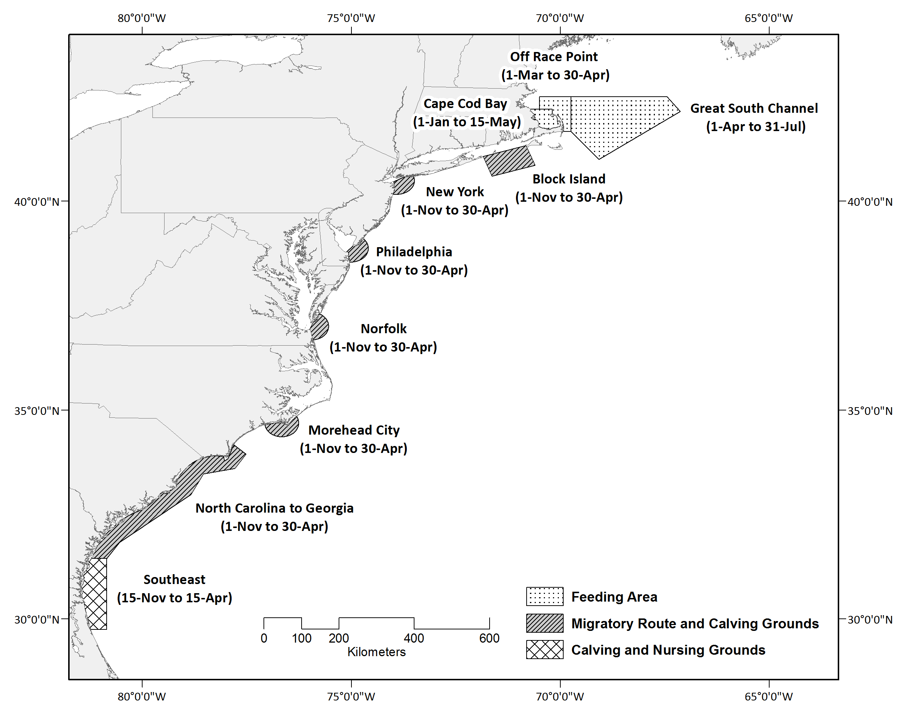
Figure 1.
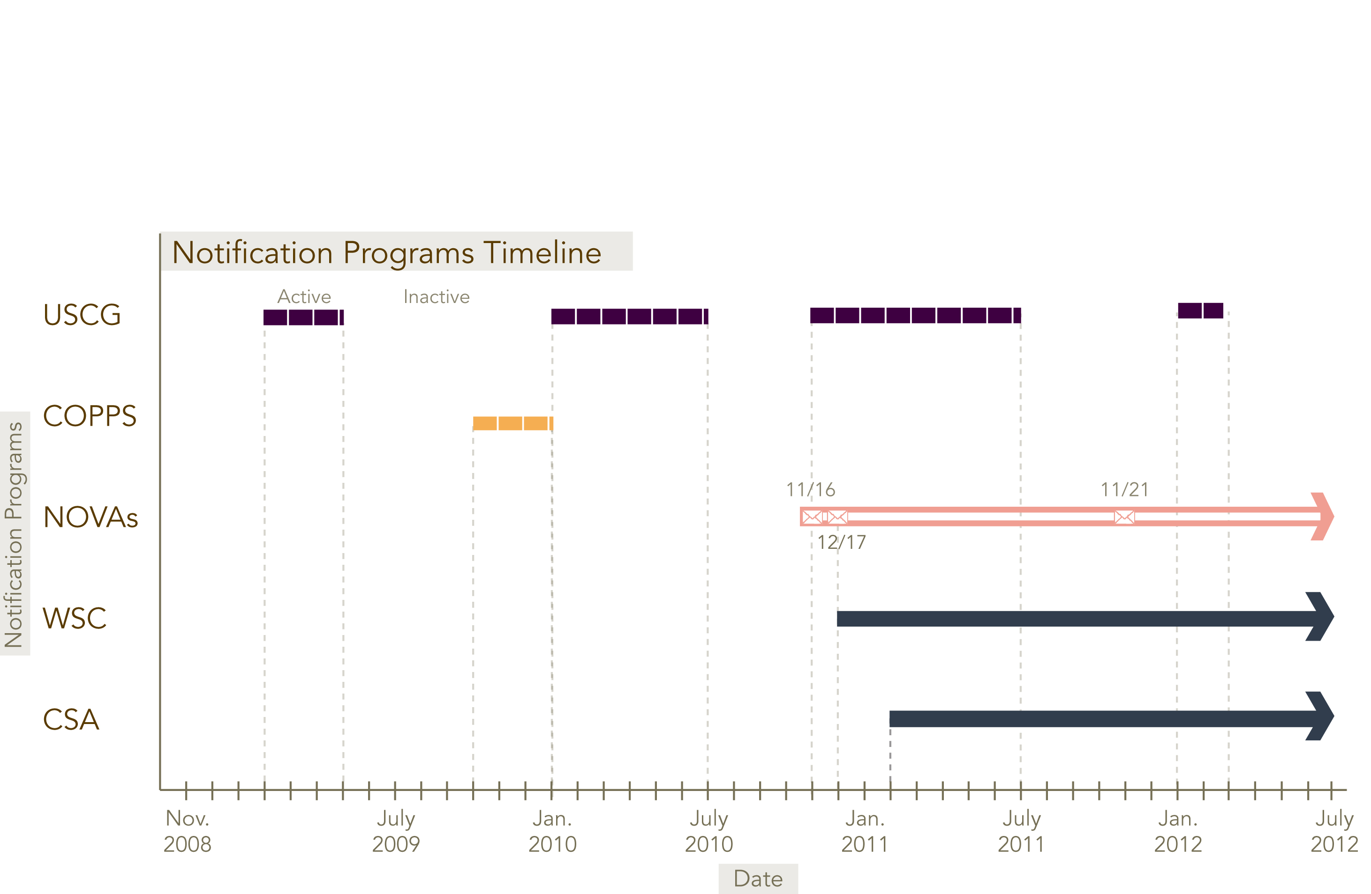

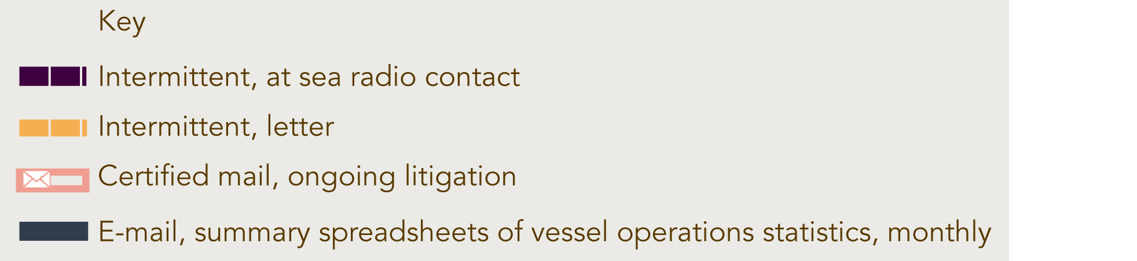

Figure 2.
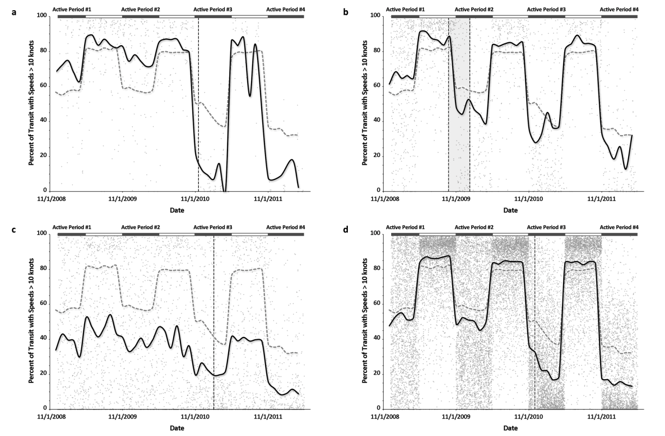

Figure 3.
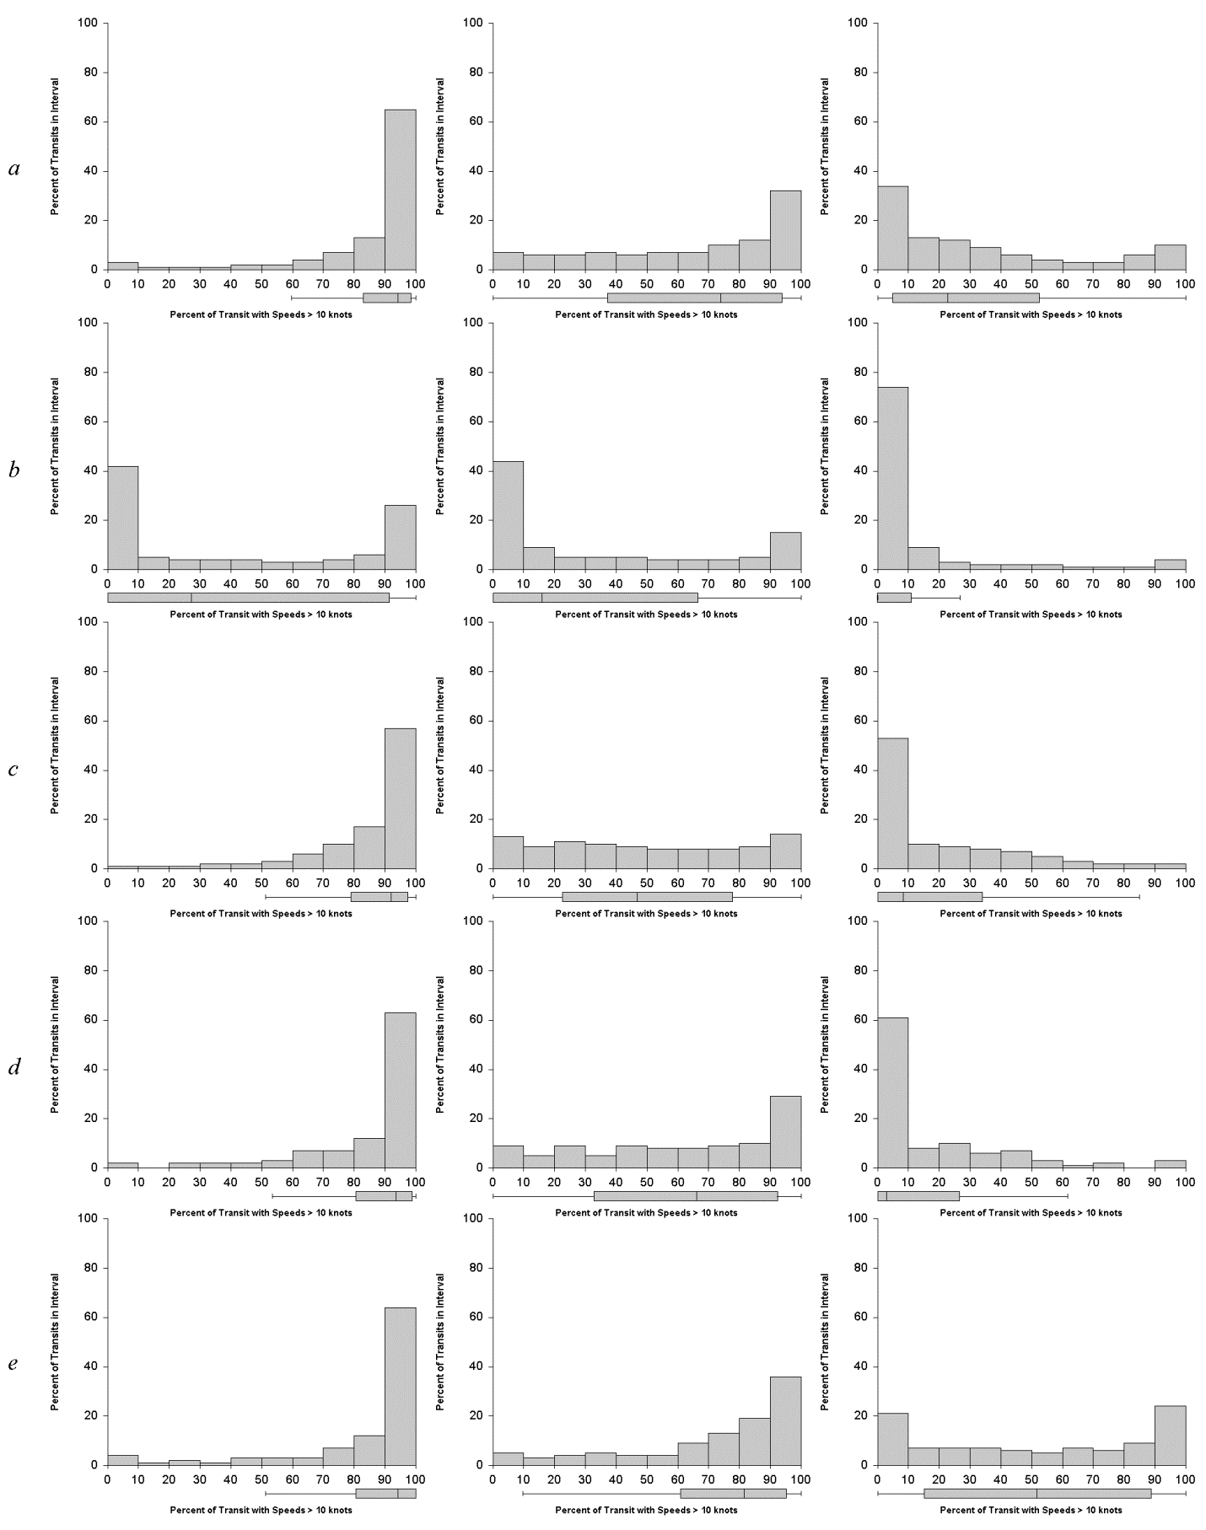
Figure 4.

